UMSL - JAVA NOTES

Object Oriented Programming Concepts
Table of Contents
- Object Oriented vs. Procedural Programming
- Procedural & OO Designs for a Sample Problem
- Object Oriented Programming Features & Benefits
- Object Oriented Methodology
- The Object Model
- Characteristics of the Object Oriented Approach
- Identifying Object Classes
- Class Identification Example
- Sample Java Class Definition
- Exercises

Object-Oriented Programming vs. Procedural Programming
Procedural Approach
- Data Structures can be represented as a network of associated structures, referring to one another.
- Procedures can be represented as a network of routines which call one another, i.e., "call tree"
Object Oriented Approach
- Collection of discrete objects that incorporate data structures and behavior.
- Each data structure has, combined with it, the procedures which apply to that data structure.
- Contrasts with conventional programming in which data structures and behavior are only loosely connected
- These entities, called objects, can be associated to one another in one network, rather than two.

Sample Problem Statement
The requirement is for a software system that will manipulate the hardware for traffic control located at an intersection. The hardware includes a set of sensors, the traffic lights, and the control box. The software reads the state of the sensors, determines the new state for the intersection, and signals the lights to change. In addition, the system is to have other capabilities such as a test option which cycles the lights through the set of configurations. The system can also be set to a default state which might be flashing yellow in one direction and red in the other. The sensor indicates the presence (or absence) of a vehicle in a particular lane. There are several kindsof sensors, Mach of which works differently internally. All the sensors however are interrupt-driven and a bit is set whenever the sensor is tripped. After the decision to change the state of the intersection, every sensor is reset. This particular intersection uses two kinds of traffic lights. One is the usual three color light which is used for the go-straight lanes. The other light is a four position light: red, yellow, green, and turn arrow. Each light has a current state, a set of valid next states, and a default state. The controller physically contains the switches for the lights, the data stores for the sensors, and a clock for timing the state of the poll/decision cycle. The controller software reads the clock, polls the sensors, determines the next state, and sends the signals to change the lights.
- Procedural System Design for the Sample Problem
- Object Oriented System Design for the Sample Problem

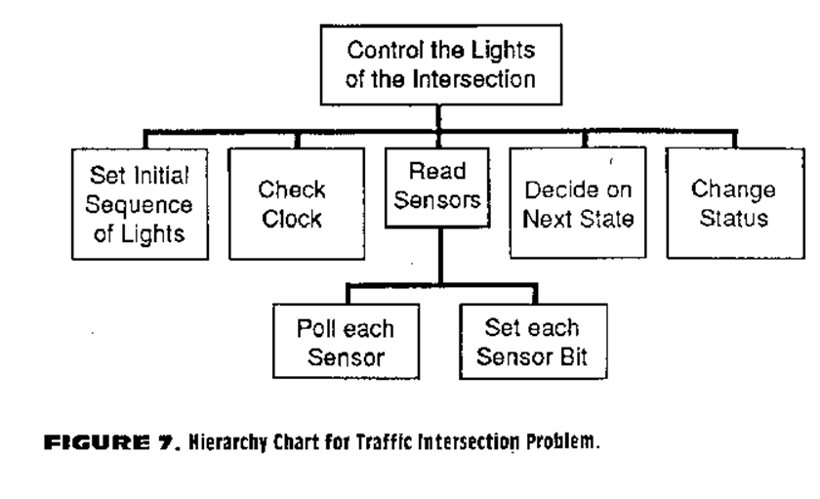

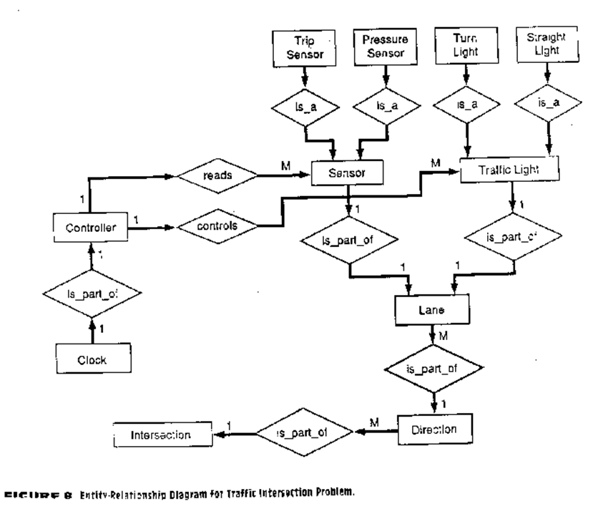

OOP Features
- Data Abstraction
  - User Need Not Worry About Implementation Details
- Data Encapsulation
  - Information Hiding
- Inheritance and Information Sharing
  - Eliminates Duplication of Data and Behaviors
  - Depicted with an Inheritance Diagram
  - Multilevel Inheritance is depicted with an Inheritance Hierarchy Diagram
- Object Structure before Implementation Details
  - Allows for More Analysis Prior to Implementation

Benefits of OOP
- Analysis and Design Made Easier
- Code Reuse
- Ease of Maintenance and Enhancement
- Iterations Fewer and Shorter

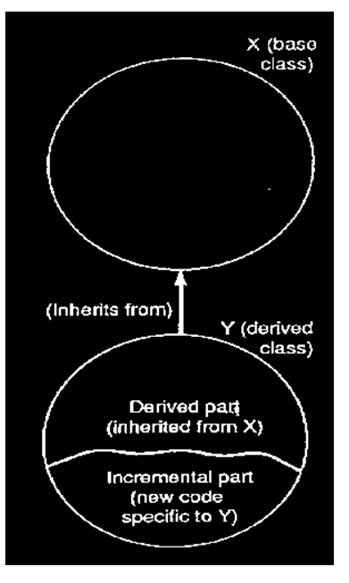

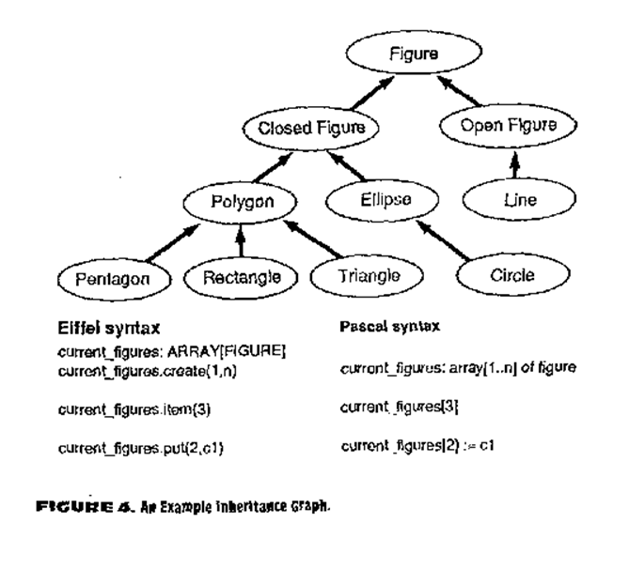

Object-Oriented Methodology
Analysis
- Define model in terms of what is to be done.
- Objects at this level are application domain concepts.
System Design
- System decomposition based on the analysis.
- Performance and system resources.
- Define specifications such as communication protocols or memory management requirements.
Object Design
- Based on the analysis model with implementation details.
- Augment objects from analysis with data structures and required algorithms to implement each class
Implementation
- Based on the system design.
- Classes, Attributes, and Operations implemented in a language

The Object Model
- Derived from problem statement
- Represents static structure
- Organized into workable pieces
- Classes, relationships and behavior
- Knowledge Sources
  - Problem Statement
  - Expert
  - General
- Promotes Interaction in Knowledge Gathering
- Iterative Processes

Defining an Object Model
- Identify Objects and Classes
- Prepare Description for Each Entity (Data Dictionary)
- Identify Associations and Aggregations
- Organize and Simplify Using Inheritance
- Iterate and Refine the Model
- Group Classes Into Modules

Characteristics of the OO Approach
- Identity
- Classification
- Polymorphism
  - Objects Exhibit Different Behaviors Depending on the Context of the Call
- Inheritance
  - Objects can "Inherit" Attributes from Other Objects in Addition to Having Their Own Unique Attributes

Identity
- Data organization using objects which are:
  - Discrete, distinguishable entities
  - Concepts, abstractions with well defined boundaries
  - Represent real-world knowledge
  - Examples of Objects
    - Paragraph or Image in a document
    - Person working in a Factory
    - A Scheduling Policy

Attributes, Operations, And Methods
  - Objects have Attributes, e.g.,
    - An Attribute of a Paragraph Object is the Paragraph Length
    - An Attribute of a Factory Worker Object is the Skill Level
    - An Attribute of a Company Policy Object is the Implementation Date
  - These Attributes have Values
    - 57 characters (Paragraph Length)
    - Novice (Skill Level)
    - 1997 (Implementation Date)
  - These Objects Also have Operations (Behaviors):
    - displayThisParagraph
    - weld Part
    - implementPolicy
  - A Specific Implementation of an Operation is Called a Method.

Classification
- Objects with the same attributes, operations, relationships to other objects, and common semantics that can be grouped into classes.
- Sometimes called object classes.
- Examples: Paragraph, Factory Worker, Company Policy
- Class is an abstract concept that describes general attributes and operations for all objects grouped together.
- Classes do not have values for attributes, objects do.
- Each object "knows" its class. Many object-oriented languages allow access of class name at one time.
- Rumbaugh refers to objects as "object instances" to help remember that an object is always an instance of some class.
- Objects are depicted using "Instance Diagrams"
- Similar diagrams for classes are called "Class Diagrams"
- Click Here to See an Example of Classes and their Object Instances

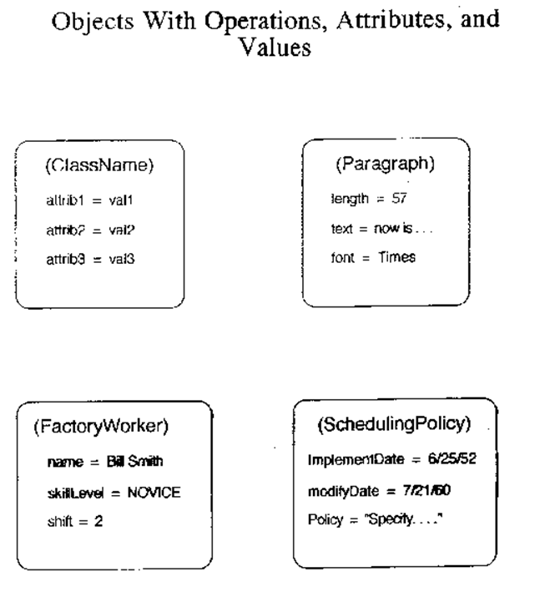

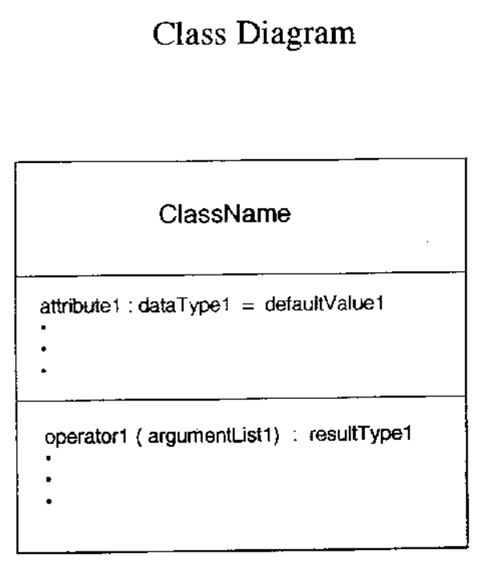

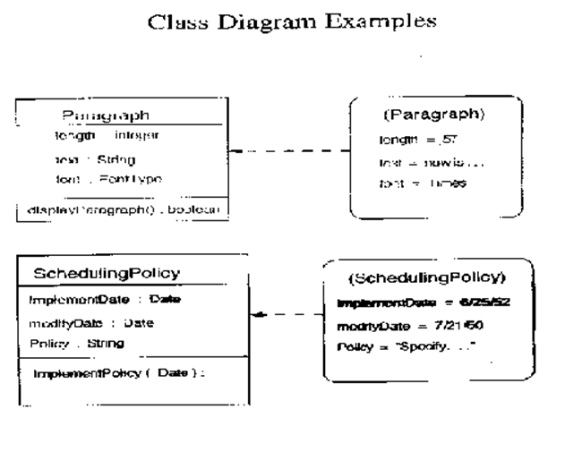

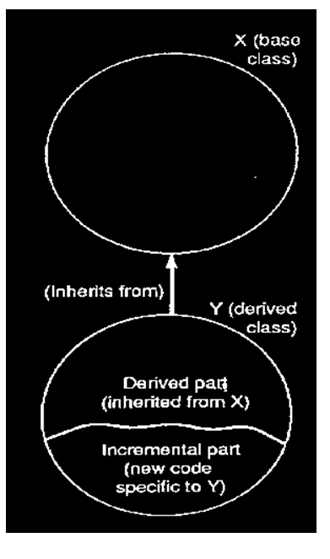

Identifying Object Classes
- Class definition must be pertinent to the domain
- Implied vs. Explicit Knowledge
- Classes often correspond to Nouns
- If attributes, operations, or roles have attributes of their own, they should be modeled as classes.
- Choose meaningful names

Refinement by Eliminating Unnecessary Classes
- Eliminate Redundancy
- Keep the Class with the Most Meaningful Name
- Eliminate Irrelevant for Problem Domain
- Eliminate Not Needed for Solution of Problem
- Eliminate Fuzzy Classes
  - Can be described by more specific class name
- Eliminate Class if it has One Attribute, it is Probably an Attribute of Some Other Class
- Don't Focus on Operations (Behaviors)
  - These Can Be Determined More Easily in Later Stages

Example

Problem Statement:
A simple cash register has a display, an electrical wire with a plug, and a numeric keypad which has keys for subtotal, tax, and total. This cash storage device has a total key which triggers the release on the drawer. The numeric buttons simply place a number on the display screen, the subtotal key displays the current total, the tax key computes the tax, and the total key adds the subtotal and the tax. Write a system to simulate the cash register described here.
Nouns (often helps to put adjectives also.)
- Cash Register
- Display
- Wire
- Plug
- Numeric Keypad
- Keys
- Device
- Total Key
- Release Drawer
- Numeric Buttons
- Subtotal Key
- Tax Key
- Screen
- Number
- Total Tax
Nouns (General Knowledge)
- 0-9 Keys
- Money

Eliminating Unnecessary Nouns
Cash Register
Display
Wire <--Irrelevant
Plug <--Irrelevant
Numeric Keypad
Keys
Device <--Vague
Total Key
Release <--Irrelevant
Drawer
Numeric Buttons <--Redundant
Subtotal Key
Tax Key
Screen <--Redundant
Number <--Attribute
Total <--Attribute
Tax <--Attribute
0-9 Keys
Value <--Attribute
Money

Simple Class Definition in Java

ACCESSSPECIFIER class CLASSNAME{
attributes, behavior
};
Example:
public class Position {
private int x;
private int y;

public void setX(int x){
this.x = x;
}

public void setY(int y){
this.y = y;
}
}

Exercises
1. | Identify the relevant classes for the following:  An electronics store needs to maintain an inventory of electronic equipment which might be found there. You should include audio as well as video equipment. Keep information on all equipment such as manufacturer, cost, date purchased, and serial number. For the audio equipment, keep track of whether it is a cassette player, a CD player, or a radio. Video equipment should be categorized as VHS, 8MM, or video disk.
2. | Identify the relevant classes from the following problem specification:  Write a program that will identify the correct oil filter for every year of every model of car made by domestic car manufacturers. The user will first select a manufacturer from the total list of manufacturers, then select a model from those made by that manufacturer, and the n select a year based on the years the model was manufactured. At this point the program should list data on any applicable filters, including part number and price.
3. | Identify the relevant classes from the following problem specification:  Write a program that will keep track of scheduled appointments in a multidoctor practice. When a patient makes an appointment, they should be mailed a confirmation card that states the time, date,and doctor of the appointment. The system should be able to print out the list of each day's scheduled appointments. Each doctor has one weekday where they go golfing and should have no appointments scheduled for that day.

An Overview of Java
- A Minimal Java Program
- Variables, Constants, and Identifiers
- Expressions
- Data Types
- Control Structures: Selection
- Control Structures: Iteration
- Methods
- Console I/O
- Utility Class for Console I/O

A Minimal Java Program

/** This is how multi-line javadoc comments are written in Java
* Program: Minimal.java
* Author: Ashok Subramanian
* Modified: 6/17/1999
*/

public class Minimal{ // The file name should be the same as the public class name

/** All Java programs must have a static public main method
* This method displays a string of text
* @param args[] Not used
*/

public static void main(String[] args){
System.out.println("Congratulations, you have successfully run your first Java program");
}
}

Variables, Constants and Identifiers
- A variable declaration associates a name with a data type and defines a new variable. Including initializers is optional,
Syntax:
type identifier [ = initializer]
Type is any valid data type in supported in Java
Identifier is any valid identifier recognized by Java. All identifiers must begin with a letter and consist of letters, numbers, underscores and $ symbols. Spaces are not permitted
- The initializer is optional. If omitted, however, the Java compiler flags as an error any attempt to access an uninitialized variable.
- Example:
int age;
float interest_rate;
char option = 'y';
boolean flag = true;
String greeting = "Hello";
Employee Joe_Smith = new Employee("Manager");
- Variables that are declared and defined within methods or blocks have local scope in that block or method. A variable only exists within its scope
- Variables that are declared and defined outside a method or block are called fields. Field are members of the class in which they are defined and have class scope
- Syntax:
[access_specifier] [qualifier] type identifier [ = initializer]
access_specifiers determine the accessibility of members of a class to other classes. There are four access levels:
Access Specifiers | Meaning
public | Accessible to members of all classes in all packages
private | Accessible only to members of the same class
protected | Accessible only to members of the same class, members of subclasses and members of classes in the same package
none specified (default) | Accessible to members of all classes in the same package
- Java recognizes a number qualifiers, one of which is static. This declares a field to be common to the whole class. Thus, static field may be accessed even if a single instance of the class does not exist. In contrast, each instance of a class has its own copy of non-static fields defined in the class
Type is any valid data type in supported in Java
Identifier is any valid identifier recognized by Java.
The initializer is optional. If omitted, Java automatically assigns a default value determined by the data type of the field. Example:
public boolean instock; // default value of false
private static int counter = 60;
private String[] message; // every element of the array of strings has a default value of null
- Unlike languages like C++, no variables, fields, and methods may be defined outside a class definition
- Constants in Java are specified by using the qualifier final, e.g.,
private static final int SIZE = 50; // defines an integer constant which is a static private field
- If an initializer is omitted the constant is called a blank final until it is initialized. After initialization a constant cannot be changed

Expressions

- Expressions can contain a single variable or constant or they may consist of operators and operands. e.g.,
int a = 2 + 2;
int b, d;
(b - 3.3) * (d + 4.175) / Math.sqrt(5.0);
- The result of an expression containing multiple operators is determined by the hierarchy of operator precedence
- The operands that comprise an expression determine its type. Thus, expressions can have types such as int, char, float, boolean, String etc. Example...
- The + and += operators are overloaded when used with String operands. They are used for string concatenation and assignment, e.g.,
String greeting = "Hello " + "World";
- Java does not support user defined operator overloading

Java Operators: Highest to lowest precedence
Operator | Description
++  --  +  -  !  (Type) | Increment  Decrement  Unary Plus  Unary Minus  Logical Not  Type Cast
*  /  % | Multiplication  Division  Modulus
+  - | Addition, String Concatenation  Subtract
<<  >>  >>> | Left bit shift  Right bit shift, sign extension  Right bit shift, zero extension
<  <=  >  >= | Less than  Less than equal  greater than  greater than equal
==  !=  instanceof | Equal  Not Equal  object type comparison
& | Bitwise and, Boolean and
^ | Bitwise Exclusive or (Xor), Boolean Xor
| | Bitwise or, Boolean or
&& | Conditional and (cand)
|| | Conditional or (cor)
? : | Conditional expression
=  +=  -=  *=  %=  /=  <<=  >>=  >>>  &=  |=  ^= | Assignment operators

Data Types

- Like C++, Java is a strongly typed language.It enforces a comprehensive set of rules about how objects of differing types are used. This ensures that appropriate storage is allocated for the various types, and also ensures that objects remain true to their intended behavior. For example, there are limitations on casting or using an object as though it has a different type than its true type.
- Every variable in Java belongs to one of two types: Primitive types or Reference types
- Primitive types are predefined types for single data items such numbers characters, or boolean values
- Reference types are aggregates, including classes and arrays
- The following lists the types and the category to which they belong:
Type | Category | Description
boolean | primitive | single bit type. Logical value true or false
char | primitive | 16 bit integral type that holds the representation of a single character using the UNICODE coding scheme
byte | primitive | 8 bit signed integral value
short | primitive | 16 bit signed integral value
int | primitive | 32 bit signed integral value
long | primitive | 64 bit signed integral value
float | primitive | 32 bit floating point value. Precision upto 6 digits after the decimal
double | primitive | 64 bit floating point value. Precision upto 12 digits after the decimal
array | reference | indexed set of elements of the same primitive or reference type
class | reference | object that can contain data and behavior
interface | reference | specification of behaviors that a class may implement
- Variables of type char, byte, short, and int are converted to ints when performing arithmetic. Therefore, explicit casting may required to assign this temporary int value to a narrower type such as byte or short. Example:
short dividend = 2927, divisor = 71;
byte remainder = dividend % divisor; // invalid - requires a cast
- Objects of reference type are created (intantiated) by using the new operator. Example:
SomeType A = new SomeType(); // Instantiates object of type Sometype and defines reference A to the object
- The identifiers of a primitive type refer to the value stored in the type, however, the identifier of a reference type is the name of an object reference using which the object can be accessed. The object itself has no name. References are implemented as pointers to storage locations of objects. Thus, object references are entities separate from the objects to which they refer
- The JVM keeps track of the number of references associated with an object. When an object has no remaining object references, the object cannot be accessed, and the system deletes the object from memory. This is called garbage collection. Unlike C++, Java does not permit the deleteion of objects of reference type explicitly. Example:
SomeType A = new SomeType(); // Instantiate SomeType object and define reference A
SomeType B = new SomeType(); // Instantiate SomeType object and define reference B
// Note the two objects have different contents
A = B; // Assigns the reference B of the second object to the reference A of the first object
- The above lines of code cause A and B to refer to the same object (the second one). The first object, which has no more existing references, will be deleted from memory by the garbage collector

Control Structures: Selection (Conditional Expressions)
- The ? : operator
- Allows the building of a new expression using three other expresssions
expression_1 ? expression_2 : expression_3
- Either expression_2 or expression_3 is evaluated depending
on the truth value of expression_1
- False is represented by a 0 value and true by any non-zero value
- For example, the following returns the larger of two values:
return(a < b ? b : a)

- The if statement
- Form 1: if (expression) statement_1
- Form 2: if (expression) statement_1; else statement_2
- Blocks of statements (compound statements) may also be used
- The logical &&, || operators can be used to evaluate multiple expressions in the if statement
- if statements may also be nested
- Example...

- The switch statement
- Syntax:
- switch (expression)
- {
- case constant1: {statement ... statement}
- case constant2: {statement ... statement}
- ...
- default: {statement ... statement}
}
- No variable is allowed in the constant expression to the left of the colon
- The constant prefix may occur more than once before a sequence of statements
- The break statement is used to jump out of a switch block
- Example of a switch statement...

/************************************************************
Source: asg4.java
Author: Ashok Subramanian
Comment: This program utilizes utility class KbdInput in
order to read primitive data types from the keyboard.
Assumes KbdInput.class file exists in the current directory.
All IOExceptions are handled by KbdInput
*************************************************************/
import KbdInput;
public class asg4 {
public static void main(String [] args) {
int input, sumA, sumB, sumC, sumD, sumF;
sumA=sumB=sumC=sumD=sumF=0;

KbdInput kbd = new KbdInput();
input = kbd.readInt();

if(input==-99) System.exit(1);

while(input != -99){

if(input>=90){
sumA++;
System.out.println(new Integer(input) + " A");
}
else if(input >= 70){
sumB++;
System.out.println(new Integer(input) + " B");
}
else if(input >= 50){
sumC++;
System.out.println(new Integer(input) + " C");
}
else if(input >= 35){
sumD++;
System.out.println(new Integer(input) + " D");
}
else{
sumF++;
System.out.println(new Integer(input) + " F");
}

input = kbd.readInt();
}

System.out.println("The total number of A's is " + new Integer(sumA ));
System.out.println("The total number of B's is " + new Integer(sumB ));
System.out.println("The total number of C's is " + new Integer(sumC ));
System.out.println("The total number of D's is " + new Integer(sumD ));
System.out.println("The total number of F's is " + new Integer(sumF ));
}
}

An Example of a switch Statement

import KbdInput;

int whichFloor()
{
int telephone_number;
telephone_number = kbdInput.readInt();
switch (telephone_number)
{
case 6279:
case 6127:{
System.out.println("This is on the 2nd floor of CCB");
break;
}
case 6520:{
System.out.println("This is on the 3rd floor of CCB");
break;
}
default: {
System.out.println("Invalid Telephone Number");
break; //not required
}
}

return(0);
}

Control Structures: Iteration
- The do-while statement
  - Syntax: do { statements } while (boolean_expression);
  - Statements in the block are executed iteratively while boolean_expression is true. The expression is evaluated at the end of each iteration. The block of statements is guaranteed to be executed at least once
  - Example of a do-while loop

- The while statement
  - Syntax:
while (boolean_expression){ statements }
  - While expression is true, the statements in the block are excuted iteratively. The boolean_expression is evaluated at the end of each iteration
  - Example of a while loop

- The for statement
  - Syntax:
for (expression_1; expression_2; expression_3){ statements }
  - Usually is a more compact substitute for the while and do-while loops
  - For example the following two loops are equivalent:
int i = 1;  while ( i <= n )  {  int s += i;  i++;  } | for (int i = 1; i <= n; i++)  int s += i;
  - Any of the expressions can be omitted from the statement, making the following statement valid:
for ( ; i > 0 ; ){ ... }

- The logical &&, || operators can be used to evaluate multiple expressions in the while and do-while and for loops
- The comma operator can be used to evaluate more than one expression in the loop. For example:
for ( int i = 0, int j = 1; j > 0; i++){ ...}
- The break statement may be used to break out of a loop
- The continue statement causes a jump to the evaluation of the expression for loop termination
- When two loops are nested, each iteration of the outer loop is accompanied by a complete execution of the inner loop
- Exercises... OOEmployee Program...

An Example of a do-while Loop

/**************************************
There is a logical flaw in this program
***************************************/
import Kbdinput;

float average()
{
int num = 0, count = 0, total = 0;
KbdInput kbd = new KbdInput();
do {
System.out.print("Enter a whole number, and -99 to quit: ");
num = kbd.readInt(); // accept input
count++; // increment counter
total += num; //accumulate the sum
} while (num != -99); // test the condition
float average = (float) total/count;
System.out.println("You keyed in " + new Integer(count) + " numbers \n");
System.out.println("The average is: " + new Float(average));
return(average);
}

An Example of a while Loop

/**********************************************************************
This method also has the same flaw as the doWhile method
**********************************************************************/
import KbdInput;

float whileLoop()
{
int num = 0, count = 0, total = 0;
KbdInput kbd = new Kbdinput();

while (num != -99) { // test the condition
System.out.print("Enter a whole number, and -99 to quit: ");
num = kbd.readInt(); // accept input
count++; // increment counter
total += num; //accumulate the sum
}
float average = (float) total/count;
System.out.println("You keyed in " + count + " numbers \n");
System.out.println("The average is: " + new Float(average));
return(average);
}

/**********************************************************************
This is the debugged version of whileLoop
**********************************************************************/

import KbdInput;

float whileLoop()
{
int num, count = 0, total = 0;
KbdInput kbd = new Kbdinput();

System.out.print("Enter a whole number, and -99 to quit: ");
num = kbd.readInt(); // accept input

while (num != -99) { // test the condition
count++; // increment counter
total += num; //accumulate the sum
System.out.print("Enter a whole number, and -99 to quit: ");
num = kbd.readInt(); // accept input
}

float average = (float) total/count;
System.out.println("You keyed in " + count + " numbers \n");
System.out.println("The average is: " + new Float(average));
return(average);
}
Exercises: Control Structures
1. | Write a program that will find the product of a collection of data values. The program should ignore all negative values and terminate when a zero value is encountered.
2. | Write a program to read in a collection of integer values, and find and print the index of the first occurrence and last occurence of the number 12. The program should print an index value of 0 if the number 12 is not found. The index is the sequence number of the data item 12. For example if the eighth data item is the only 12, then the index value 8 should be printed for the first and last occurrence.
3. | Write a program to find the minimum, maximum, and average values of a collection of data values. The number of data values is unspecified.
4. | Write a program to read in a collection of exam scores ranging in value from 0 to 100. The program should count and print the number of A's (90 to 100), B's (70 to 89), C's (50 to 69), D's (35 to 49) and F's (0 to 34). The program should also print each score and its letter grade. Use the following test data:  63 75 72 72 78 67 80 63 0 90 89 43 59 99 82 12 100 75

**********************************************
Source: OOEmployee1.java
Author: Ashok Subramanian
*********************************************/

public class OOEmployee1{
/*********************
Attributes
*********************/
float rate;
float taxrate;
int hours;
float gross;
float ot;
float tax;
float net;
float net_percent;
String JobCode;
String Name;

//End Attributes

/********************
Methods
********************/

public OOEmployee1(String n, String jc, int h){
rate=30.0f;
taxrate=0.2f;
hours=h;
Name=n;
JobCode=jc;
}

public void computeGross() {
if(hours<40)
gross=rate*hours;
else gross=(40*rate)+computeOT();
}

private float computeOT(){
if(JobCode.equals("Admin"))
ot = (hours-40)*50.0f;
else
ot = (hours-40)*40.0f;
return(ot);
}

public void computeTax() {
tax=gross*taxrate;
}

public void computeNet() {
net=gross-tax;
}

public void computeNetperc() {
net_percent=(net/gross)*100;
}

public void displayEmployee() {
System.out.println("Name: " + Name);
System.out.println("Job Code: " + JobCode);
System.out.println("Hours: " + hours);
System.out.println("Rate: " + rate);
System.out.println("Gross: " + gross);
System.out.println("Over Time Earnings: " + ot);
System.out.println("Net: " + net);
System.out.println("Net%: " + net_percent + "%");
}
//End Methods

} // End class OOEmployee1

/*********************************************
Source: OOEmployee1_driver.java
Author: Ashok Subramanian
*********************************************/
import KbdInput;
import OOEmployee1;

/* The above is optional if the required class
*** is in the same package. If the class is
***in a different package the full path must
***be specified in the import statement
*/

public class OOEmployee1_driver{
public static void main(String[] args) {
String option = "y";
while (option.equals("y")){
System.out.print("Enter Employee Name: ");
String name = KbdInput.readString();
System.out.print("Enter Employee Job Code (Admin/Line): ");
String jc = KbdInput.readString();
System.out.print("Enter Hours Worked: ");
int hours = KbdInput.readInt();
OOEmployee1 EmpObj = new OOEmployee1(name, jc, hours);
EmpObj.computeGross();
EmpObj.computeTax();
EmpObj.computeNet();
EmpObj.computeNetperc();
EmpObj.displayEmployee();
System.out.print("Continue (y/n)? ");
option = KbdInput.readString();
}
} // End main
} // End class OOEmployee1_driver

Methods

- Every Java method is a member of a class (member functions in C++). Unlike C++, Java does not permit stand-alone methods/functions
- All method declarations include the return type, method name, argument list, and the body/implementation of the method.
- Syntax:
[access_specifiers] [qualifiers] return_type method_name (argument_list) [throws exception_list]
block
Methods, like fields, can specify public, private, protected, and the default package access specifiers
Qualifiers are optional. Use static to specify a class-wide method
Return_type is not optional. Specify void if the method does not return any value
The method name must be a valid identifier.. By convention lowercase is used for method names. If the method name comprises multiple words, then the first letter of each word is capitalized except the first word, e.g., myMethod(), getMarketShare() etc.
The parentheses must always be present. They contain the argument_list of the method. If the method takes no argument, use empty parentheses
The throws exception_list clause is optional. This clause lists the exceptions (errors) that can occur while the method is running. Exceptions listed in the throws clause are assumed to be handled by the caller of the method
The body of the method is any number of statements enclosed in braces {}
- Example:
long getMax(long first, long second) {
if (first > second) return first
else return second;
}
- All arguments are passed by value in Java. When arguments are primitive types, copies of their values are passed to the method. However, when arguments are reference types, copies of references to the objects are passed - copies of the object are not passed. Example:
/* The following method will not be successful in swapping the two variable values */
public class NoGoodSwap {
public void swap(int a, int b) {
int temp = a;
a = b;
b = temp;
}
}
/* However, the following method will be successful in swapping the two variable values */
public class NoGoodSwap {
public void swap(int[] SwapArray) {
int temp = SwapArray[0];
SwapArray[0] = SwapArray[1];
SwapArray[1] = temp;
}
}
- A method with a specified return type can only return one object. A Method with a void return type does not return anything
- The main method serves as the entry point into the program. Any class can have a main method and more than one class that is used in the application can have a method named main. It is handy to have a main method for almost every class in an application because this enables each class to be compiled and tested in a piecemeal fashion.
- The Java Virtual Machine (JVM) (which is activated by issuing the java file_name command) looks for the public class (in the specified .class file) with the same base name as the file name. Next the JVM looks in that class for a method named main. If no such method exists an error message is displayed. If main is found, the JVM passes control to it. The syntax for main is as follows:
public static void main(String [] args) [throws exception_list]
the JVM does not recognize main as the entry point unless it is declared public, staic and has a return type of void.
It has a single argument, which is an array of Strings. This argument is provided when the JVM is activated, e.g.,
java MyApp testing
the String "testing" is the first argument of the args[] array
Console I/O

- Console I/O means input from the keyboard, and output to the screen.
- Java provides basic and effective methods for performing console I/O, however, they are not as powerful or elegant as features provided in C++
- Java, however, provides a rich set of methods and classes for developing GUI for I/O purposes. These will be discussed later.
- I/O in Java are conceptualized as streams of bytes. These streams are 'attached' to stream objects at one end and to the program at the other.
- These stream objects are public, static, final fields of the core class System in the java.lang package
- The following are the stream objects for console I/O:
Stream Object | Type | Default Device
java.lang.System.in | java.io.InputStream | Keyboard
java.lang.System.out | java.io.PrintStream | Screen
java.lang.System.err | java.io.PrintStream | Screen
- The print and println methods of the PrintStream class are usually used for outputting data to the screen, e.g.,
int id = 20;
System.out.println(id);
- The println method inserts a newline at the end of the line, whereas the print method does not
- Console input is more complicated than output because the input usually has to be parsed before processing can occur
- It is preferable to read input one line at a time because this allows the user to utilize the line editing features of the operating system. After the enter key is pressed, the entire line can be read as a string and subsequently parsed to retrieve individual data values
- The following code demonstrates simple console I/O:
package console; // This class will be added to the package console
/** A class to demonstrate simple console I/O
*/
import java.io.*; // specify package to search for io classes
import java.util.*;
public class ConsoleTest {
/** The test method for the class
* @param args not used
* @exception java.io.IoException
* unspecified I/O exception
*/
public static void main(String[] args) throws IOException {
int i = 10;
int j = 20;
double d = 99.101;
System.out.print( "Here are some values: " );
System.out.println( i + " " + j + " " + d );
System.out.println( "Enter an integer, a float, and a string:" );
BufferedReader br;
br = new BufferedReader( new InputStreamReader( System.in ) );
String line = br.readLine();
StringTokenizer st = new StringTokenizer( line );
int k = Integer.parseInt( st.nextToken() );
float f = Float.valueOf( st.nextToken()).floatValue();
String s = st.nextToken();
while( st.hasMoreTokens() ) {
s += " " + st.nextToken();
}
System.out.println( " Here's your data:" );
System.out.println( k );
System.out.println( f );
System.out.println( s );
}
}
Output:
Here are some values: 10 20 99.101
Enter an integer, a float, and a string:
13 34.6 Quick brown fox
Here's your data:
13
34.6
Quick brown fox

import java.io.*;
public class KbdInput{
public static int readInt() {
int i=0;
BufferedReader br = new BufferedReader(new InputStreamReader(System.in));
try{
String s = br.readLine();
i = Integer.parseInt(s);
}
catch(IOException ioe){
ioe.printStackTrace();
}
return(i);
}

public static float readFloat() {
float f=0;
BufferedReader br = new BufferedReader(new InputStreamReader(System.in));
try{
String s = br.readLine();
f = Float.parseFloat(s);
}
catch(IOException ioe){
ioe.printStackTrace();
}
return(f);
}

public static double readDouble() {
double d=0;
BufferedReader br = new BufferedReader(new InputStreamReader(System.in));
try{
String s = br.readLine();
d = Double.parseDouble(s);
}
catch(IOException ioe){
ioe.printStackTrace();
}
return(d);
}

public static String readString() {
BufferedReader br = new BufferedReader(new InputStreamReader(System.in));
String s="";
try{
s = br.readLine();
}
catch(IOException ioe){
ioe.printStackTrace();
}
return(s);
}

}

Classes
- Basic Concepts of Classes
- Constructors
- Static Members
- Packages

Classes & Objects
Classes
- Classes are the building blocks of an object oriented program
- Classes extend structs by encapsulating data members along with the functions that operate on these data members
- Thus, a Class definition specifies its data members (attributes) as well as its member functions (methods)
- Variables that belong to classes are referred to as "objects". Objects are concrete "instances" of a class
- Classes are "instantiated" by defining objects. This results in memory being allocated to store the object
Student John_Doe = new Student();
The above statement creates a Student object which may be accessed using the John_Doe reference
- Access to attributes and methods is accomplished using the . (dot) operator
- The access specifier defines the degree of accessibility of individual class members
  - public members may be accessed by members of same object, and by functions outside the scope of the class
  - package (default access level) members may be accessed by methods of the same object, and by methods outside the scope of the class but within the same package (folder)
  - private members may only be accessed by methods of the same object
- When methods of an object are invoked to operate on data members, it is not necessary to specify the object name of the data member being operated on. In other words, it is not necessary to use the . (dot) operator
- Example...
- Employee Payroll Example...
- Another Employee Payroll Example...
- Exercise...

class Date {
private int day;
private int month;
private int year;

public void init(int m, int d, int y){
day = d;
month = m;
year = y;
}

public void print(){
System.out.println("The date stored in this object is:");
System.out.println( "Day: " + day);
System.out.println( "Month: " + month);
System.out.println( "Year: " + year);
}

public static void main(String[] args){
int day, month, year;
Date today = new Date();

today.init(11, 20, 2005);
today.print();
}

/*********************************************
Source: OOEmployee1.java
Author: Ashok Subramanian
*********************************************/

public class OOEmployee1{
/*********************
Attributes
*********************/
float rate=30.0f;
float taxrate=0.2f;
int hours=45;
float gross=0.0f;
float tax=0.0f;
float net=0.0f;
float net_percent=0.0f;

//End Attributes

/********************
Methods
********************/
public void computeGross() {
gross=rate*hours;
}

public void computeTax() {
tax=gross*taxrate;
}

public void computeNet() {
net=gross-tax;
}

public void computeNetperc() {
net_percent=(net/gross)*100;
}

public void displayEmployee() {
System.out.println("Hours: " + new Integer(hours));
System.out.println("Rate: " + new Float(rate));
System.out.println("Gross: " + new Float(gross));
System.out.println("Net: " + new Float(net));
System.out.println("Net%: " + new Float(net_percent) + "%");
}
//End Methods

} // End class OOEmployee1

/*********************************************
Source: OOEmployee.java
Author: Ashok Subramanian
*********************************************/

public class OOEmployee{
// Begin Methods

public float computeGross(int h, float r) {
return(r*h);
}

public float computeTax(float g, float tr) {
return(g*tr);
}

public float computeNet(float g, float n) {
return(g-n);
}

public float computeNetperc(float g, float n) {
return(n/g*100);
}

public void displayEmployee(int h, float r, float g, float n, float np) {
System.out.println("Hours: " + h);
System.out.println("Rate: " + r);
System.out.println("Gross: " + g);
System.out.println("Net: " + n);
System.out.println("Net%: " + np + "%");
}
//End Methods

public static void main(String[] args) {
float rate=30.0f;
float taxrate=0.2f;
int hours=45;

OOEmployee George = new OOEmployee();
float gross = George.computeGross(hours, rate);
float tax = George.computeTax(gross, taxrate);
float net = George.computeNet(gross, tax);
float netperc = George.computeNetperc(gross, net);
George.displayEmployee(hours, rate, gross, net, netperc );

} // End main
} // End class OOEmployee

Exercise: Methods
Develop a class that consists of methods that compute and display the sum, difference, product, quotient, and the average of two data values that are defined and passed to the methods from main

Constructors
- Class objects, like simple variables, must be initialized before they can be used. This may be accomplished by defining a method that performs the initialization, such as the init() member function in the previous example. Alternatively, a constructor may be used
- Constructors are special methods that are used to perform initializations. They are invoked as soon as an object is defined. They are syntactically distinct from the other methods because they have the same name as the class name, and they do not have a return data type. Example...
- Similar to built-in data types, arrays of objects can be defined
- Arrays of Objects may be processed just like arrays of primitive data types Example...

Class Constructor Example

class Date {
private int day;
private int month;
private int year;

public Date(int m, int d, int y){
day = d;
month = m;
year = y;
} // end constructor

public void print(){
System.out.println("The date stored in this object is:");
System.out.println( "Day: " + day);
System.out.println( "Month: " + month);
System.out.println( "Year: " + year);
} // end method print

public static void main(String[] args){
int day, month, year;
Date today new Date(11,20,2005); // Constructor call

today.print();
} //end main
} //end class Date

Array of Objects

public class Student{
private String ID;
private float Exam1;
private float Exam2;

public void setID(String s){
ID = new String(s);
}

public void setExam1(float e1){
Exam1 = e1;
}

public void setExam2(float e2){
Exam2 = e2;
}

public void showAll(){
System.out.println();
System.out.println("Student ID: " + ID);
System.out.println("Exam 1: " + Exam1);
System.out.println("Exam 2: " + Exam2);
System.out.println();
}
} // end class Student

import KbdInput;
import Student;
public class StudentArray{
public static void main(String[] args){
String id;
float ex1, ex2;
KbdInput kbd = new KbdInput();
Student[] sarray = new Student[3];

for(int i=0; i<sarray.length; i++){
System.out.print("Enter ID#: ");
id = kbd.readString();
System.out.print("Enter Exam 1: ");
ex1 = kbd.readFloat();
System.out.print("Enter Exam 2: ");
ex2 = kbd.readFloat();

sarray[i] = new Student();
sarray[i].setID(id);
sarray[i].setExam1(ex1);
sarray[i].setExam2(ex2);
}

for(int i=0; i<sarray.length; i++){
sarray[i].showAll();
}
}
}// end class StudentArray

Processing an Array of Objects

public class Student{
private String ID;
private float Exam1;
private float Exam2;

public Student(String s, float e1, float e2){
setID(s);
setExam1(e1);
setExam2(e2);
}

public void setID(String s){
ID = new String(s);
}

public void setExam1(float e1){
Exam1 = e1;
}

public void setExam2(float e2){
Exam2 = e2;
}

public String getID(){
return ID;
}

public float getExam1(){
return(Exam1);
}

public float getExam2(){
return(Exam2);
}

public void showAll(){
System.out.println();
System.out.println("Student ID: " + ID);
System.out.println("Exam 1: " + Exam1);
System.out.println("Exam 2: " + Exam2);
System.out.println();
}
}// end class student

import KbdInput;
import Student;
public class StudentArray{
public static void main(String[] args){
String id;
float ex1, ex2;
KbdInput kbd = new KbdInput();
Student[] sarray = new Student[3];

for(int i=0; i<sarray.length; i++){
System.out.print("Enter ID#: ");
id = kbd.readString();
System.out.print("Enter Exam 1: ");
ex1 = kbd.readFloat();
System.out.print("Enter Exam 2: ");
ex2 = kbd.readFloat();

sarray[i] = new Student(id, ex1, ex2);
}

for(int i=0; i<sarray.length; i++){
sarray[i].showAll();
}

System.out.println("*********Students with Average above 75.00**********");
for(int i=0; i<sarray.length; i++){
float avg = (sarray[i].getExam1() + sarray[i].getExam2())/2;
if(avg > 75.0f){
sarray[i].showAll();
System.out.println("Average: " + avg);
}
}
}
}// end class StudentArray

Static Members
- Static fields and methods are shared by all objects of a class. In other words, static fields and methods are not members of any instance, instead they belong to the entire class. Hence, they are often referred to as class variables and class methods. This means that it is not necessary to instantiate an object in order to access a static member of a class. Class variables , may be initialized in the class definition just like instance variables. They may also be initialized in a static block. Example:

- static {
- int counter = 0;
- float balance = 100f;
- float interest = .05f;
- }
- Class methods can only operate on class variables. A typical use of class methods is to implement a class-wide utility, and standard application of a class variable is to count the number of active instances of a class. Example...

Class Variables

/** A Java class to demonstrate how static members
* are defined, initialized, and used.
*/
public class Counted {

private int value;
private static int count = 0; // simple init clause

/** Default constructor method */
public Counted() {
++count;
System.out.println( "Creating a "
+ "Counted object" );
value = -1;
}

/** Class finalizer */
public void finalize() {
--count;
System.out.println( "Destroying a "
+ "Counted object" );
}

/** Method to return the number of objects
* @return The number of existing objects of
* the class
*/
public static int getCount() {
return count;
}

/** Mutator method to set the value of the object
* @param newValue The new value for the object
* @return The updated object
*/
public Counted setValue( int newValue ) {
value = newValue;
return this;
}

/** Accessor function to obtain the value of
* the object
* @return The value of the object
*/
public int getValue() {
return value;
}

/** The test method for the class
* @param args Not used
*/
public static void main( String[] args )
{
Counted a = new Counted();
Counted b = new Counted();
Counted c = new Counted();
System.out.println( "There are "
+ Counted.getCount()
+ " Counted objects" );
Counted d = new Counted();
System.out.println( "There are "
+ Counted.getCount()
+ " Counted objects" );
a = null;
System.gc(); // start garbage collection
System.runFinalization();
System.out.println( "There are "
+ a.getCount()
+ " Counted objects" );

/* without the next three method calls, the
* objects b, c, and d would be picked up in
* the preceding garbage collection
*/
b.setValue( 1 );
c.setValue( 2 );
d.setValue( 3 );
}
}

Packages
- Java classes are grouped into packages.
- All classes - core classes as well as programmer developed classes belong to a package
- The Java core classes are grouped into packages based on their logical relationships to each other. Thus all I/O classes are grouped into the package java.io
- If a default level of access is not specified for a member of a class - a default package level accessibility is assumed. This mimics the C++ friend classes and functions
- Just as a .java file must have the same name as the only public class in the file, a package must have the same name as the subfolder (subdirectory) in which it is stored
- A package can contain any number of classes, just as a subfolder can contain any number of files
- The parent folder of the package folder must be specified in the CLASSPATH environment variable of the operating system
- In order to utilize classes from a package, the package name must be specified using an import statement, e.g.;
import java.util.*;
The above statement will allow the utilizaion of all classes in the java.util package
- If an import statement is not specified, the entire path to the classes must be specified when defining class objects, e.g.,
- java.util.StringTokenizer s;
- s = new java.util.StringTokenizer( s1 );
- Here is a list of the Java core packages
:Core java Packages
java.lang: The Java Language Package
java.io: The Java I/O Package
java.util: The Java Utility Package
java: The Java Networking Package
: Window Toolkit and Applets
java.awt: The Abstract Window Toolkit (AWT) Package
java.awt.image: The AWT Image Package
java.awt.peer: The AWT Peer Package
java.applet: The Java Applet Package

The Java Class Library: java.lang
- Arrays
- Strings
- StringBuffers
- Object
- System
- Math
- Class
- Thread
- Wrapper Classes:
Boolean
Byte
Character
Short
Integer
Long
Float
Double
- Exercises

Arrays
- What are Arrays?
- Defining and Initializing Arrays
- Passing Arrays to Functions
- Exercise...
- Array of Objects

Arrays
What are Arrays?
- In C++ an array is a group of memory locations that has the same name and stores the multiple values of the same type of data
- An array in Java, is an object. Java defines arrays as a reference data type. Therefore, an array contains mutiple objects of the same type, and the methods to operate on them
- A particular element (object) in an array object can be referenced by the array name and the location number within that name
- Example:
Array grades
Array Element | Array Element Values
grades[0] | 65
grades[1] | 72
grades[2] | 56
- In Java, just like in C and C++, the first element in the array is the zeroth element
- The array grades has three elements, numbered 0 through 2
- The array name is grades
- Each element of the array is referenced by using the array name and the position of the element within the array - this is called the subscript
- The subscripts may also be arithmetic expressions: e.g., grades[a+b], where a and b are integer values
- References to array elements outside the bounds of an array lead to ArrayIndexOutOfBoundsException being thrown
- Array bounds violation can be prevented by determining the size of the array which is stored in the length field of the array object

Arrays
Defining and Initializing Arrays
- Storage space must be reserved in memory by specifying the data type and the number of elements to be stored in the array
int[] grades = new int[3];
- The array grades that will contain 3 integer values is defined as:
int[] grades = {10, 20, 30};
- Note: In the above line, the size of the array is not specified. The compiler will determine the size based on the number of elements being used in the initialization
- Alternatively, you can declare the array on a separate line, and initailize it later. e.g.,

- int[] grades; //declares an int array reference grades
- grades = new int[] {10, 20, 30};
- The above array reference can be assigned new values as follows:
grades = new int[] {60, 70, 80};

Arrays
Passing Arrays to Functions
- In the function call, the name of the array should be specified as the actual argument (without the square brackets)
- Example:

- /*****************************************************************
- File: Array1.java
- An example of an array being passed to a function
- This program stores integers in an array
- and computes their average
- *****************************************************************/
- public class Array1 {
- public static void main(String[] args) {
- int[] scores = {5, 5, 12, 17, 11};
- float avg = averData(scores, MAX_SIZE);
- System.out.println("Average score: " + avg );
- }

- float averData(int[] numbers, int size) {
- int i, sum;
- for(i=0, sum=0; i<size; i++) {
- System.out.println( << "score " + i+1 + " = " + numbers[i] );
- sum += numbers[i];
- }

- return ( (float) sum / i );
- }
- }

- Arrays are passed by reference, not by value. This means that the array defined in one function can be modified by another

- Example:
- /**********************************************************
- File: Array2.java
- This program demonstrates that arrays are
- passed by reference
- **********************************************************/
- public class Array2 {
- public static void main( String[] args) {
- int[] scores = {5, 5, 12, 17, 11};

- System.out.println( "Before the function call...");
- for (int i=0; i<scores.length; i++)
- System.out.println( "scores[" + i + "] = " + scores[i] );

- changeVals( scores );

- System.out.println( "After the function call...");
- for (int i=0; i<scores.length; i++)
- System.out.println( "scores[" + i + "] = " + scores[i] );

- }

- void changeVals( int[] numbers ) {
- for(int i=0; i<numbers.length; i++)
- numbers[i] += 10;

- }
- }

- Output:
- Before the function call...
- scores[0] = 5
- scores[1] = 5
- scores[2] = 12
- scores[3] = 17
- scores[4] = 11
- After the function call...
- scores[0] = 15
- scores[1] = 15
- scores[2] = 22
- scores[3] = 27
- scores[4] = 21
- . Because arrays are reference types you cannot copy the contents of one array into another using the assignment operator. The System class provides a useful method - arraycopy to do this. Syntax:
void arraycopy( Object source, int SourcePos, Object destination, int destinationPos, int numbers );
- Example...

- /** class to demonstrate method arraycopy
- */
- public class MergeArrays {
- public static void main( String[] args ) {
- int[] x = { 5, 4, 0, -2, 53, -3 };
- int[] y = { 100, 101 };
- for( int i=0; i<x.length; i++ ) {
- System.out.print( " " + x[i] );
- }
- System.out.println();
- System.arraycopy( y, 0, x, 3, y.length );
- for( int i=0; i<x.length; i++ ) {
- System.out.print( " " + x[i] );
- }
- System.out.println();
- }
- }

- Output:
- 5 4 0 -2 53 -3
- 5 4 0 100 101 -3

ASSIGNMENT OPERATOR LINK
import KbdInput;
public class ArrayAssign{

void print(int[] ia){
for(int i=0; i<ia.length; i++){
System.out.print(" " + ia[i]);
}
System.out.println();
System.out.println();
}

public static void main(String[] args){
int[] ia1 = {1,2,3,4,5};
int[] ia2 = {11,12,13,14,15};

ArrayAssign AA = new ArrayAssign();
System.out.println("Array ia1: ");
AA.print(ia1);
System.out.println("Array ia2: ");
AA.print(ia2);

ia1 = ia2;
System.out.println("After Assignment ia1 = ia2: ");
System.out.println("Array ia1: ");
AA.print(ia1);
System.out.println("Array ia2: ");
AA.print(ia2);

ia1[3] = 1000;
System.out.println("After Assignment ia1[3] = 1000: ");

System.out.println("Array ia1: ");
AA.print(ia1);
System.out.println("Array ia2: ");
AA.print(ia2);

}
}

Output:

Array ia1:
1 2 3 4 5

Array ia2:
11 12 13 14 15

After Assignment ia1 = ia2:
Array ia1:
11 12 13 14 15

Array ia2:
11 12 13 14 15

After Assignment ia1[3] = 1000:
Array ia1:
11 12 13 1000 15

Array ia2:
11 12 13 1000 15

Reversing Array Contents
In the program listed below, implement the method swap() that will reverse the contents of the array scores

/**********************************************************
Source: ArraySwap.java
Author: Ashok Subramanian
Comment: This class implements a method that
reverses the contents of an array
**********************************************************/
import KbdInput;
public class ArraySwap{
int[] scores = new int[5];
void fillArray(){
KbdInput kbd = new KbdInput();

for(int i=0; i<scores.length); i++){
System.out.print("Enter value: ");
scores[i] = kbd.readInt();
}
}

void printArray(){
for(int i=0; i<scores.length; i++){
System.out.print(new Integer(scores[i]));
}

System.out.println();
}

void swap(){
// INSERT YOUR CODE HERE
}

public static void main(String[] args){

ArraySwap AS = new ArraySwap();
AS.fillArray();
System.out.println("Before calling swap...");
AS.printArray(); // display original contents of scores

AS.swap(); //Reverse the contents of scores

System.out.println("After calling swap...");
AS.printArray(); // display reversed contents of scores

}
}
Sample Solution code...

Reversing Array Contents

/**********************************************************
Source: ArraySwap.java
Author: Ashok Subramanian
Comment: This class implements a method that
reverses the contents of an array
**********************************************************/
import KbdInput;
public class ArraySwap{
int[] scores = new int[5];
void fillArray(){
KbdInput kbd = new KbdInput();

for(int i=0; i<(scores.length); i++){
System.out.print("Enter value: ");
scores[i] = kbd.readInt();
}
}

void printArray(){
for(int i=0; i<scores.length; i++){
System.out.print(new Integer(scores[i]));
}

System.out.println();
}

void swap(){
int temp;
for(int i=0, j=scores.length-1; i<j; i++, j--){
temp=scores[i];
scores[i] = scores[j];
scores[j]=temp;
}
}

public static void main(String[] args){

ArraySwap AS = new ArraySwap();
AS.fillArray();
System.out.println();
System.out.println("Before calling swap...");
AS.printArray();

AS.swap();

System.out.println("After calling swap...");
AS.printArray();

}
}

Array of Objects

public class Student{
private String ID;
private float Exam1;
private float Exam2;

public void setID(String s){
ID = new String(s);
}

public void setExam1(float e1){
Exam1 = e1;
}

public void setExam2(float e2){
Exam2 = e2;
}

public void showAll(){
System.out.println();
System.out.println("Student ID: " + ID);
System.out.println("Exam 1: " + Exam1);
System.out.println("Exam 2: " + Exam2);
System.out.println();
}
} // end class Student

import KbdInput;
import Student;
public class StudentArray{
public static void main(String[] args){
String id;
float ex1, ex2;
KbdInput kbd = new KbdInput();
Student[] sarray = new Student[3];

for(int i=0; i<sarray.length; i++){
System.out.print("Enter ID#: ");
id = kbd.readString();
System.out.print("Enter Exam 1: ");
ex1 = kbd.readFloat();
System.out.print("Enter Exam 2: ");
ex2 = kbd.readFloat();

sarray[i] = new Student();
sarray[i].setID(id);
sarray[i].setExam1(ex1);
sarray[i].setExam2(ex2);
}

for(int i=0; i<sarray.length; i++){
sarray[i].showAll();
}
}
}// end class StudentArray

Extending Classes
Basic Concepts
- The process of defining a new class based on an existing class is called extending a class. New fields and methods are added to the new subclass to give it additional capabilities and to override methods inherited from the superclass. A class can only extend one class directly. The ultimate superclass in Java is the Object class.
- Example ...
- Final classes are those classes that cannot be extended. In order to prevent a class from being subclassed define the class with the qualifier final. Examples of final classes are Integer, Float, Character, etc.
- Declare a class with the qualifier abstract if the intention is never to instantiate the class. Do this to design a class for use only as a Superclass. The only way to use an abstract class is to extend it.
- You can also declare methods to be abstract, but only within abstract classes. Abstract methods have no body and must be overridden in any extending class that is not also abstract.
- An abstract class can contain a mixture of abstract methods and fully implemented methods. This is useful in situations where some methods of the Superclass are common to the subclasses and others require specific implementations for each subclass. Example...
- Interfaces in Java provide an alternative to multiple inheritance. Unlike C++ Java does not support multiple inheritance.
- An Interface defines public methods that are abstract and have no implementations. An Interface can have fields but they must be static and final. A very important interface in Java is the Runnable Interface from the package Java.lang. The Runnable Interface defines the behavior of being capable of running as a separate thread in a multi threaded program. Threads will be discussed later. Example...
Access specifiers
  - Public access grants unlimited access to all classes.
  - Protected access gives unlimited access to classes in the same package. It also allows all subclasses to access methods, regardless of whether the subclasses are in the same package. A subclass from a different pacage can inherit fields but not access them directly. A class that is in a different package and is not a subclass has no access to protected members. Example...
  - There is no key word for default access. This access is called package access. Package access grants unlimited access to classes in the same package, but no access to classes outside the package.
  - Private access allows no access to the member from outside the class.
- The Java programming language provides an object reference super that refers to the Superclass for the current object. This reference is useful for calling methods of the Superclass such as constructors. Example...
- Constructors of the Superclass object are invoked before the constructors of subclass objects. Example...
Overriding methods
- A subclass can redefine methods inherited from the Superclass. In this way subclasses can customize behavior inherited from the Superclass. This is called method overriding. It is common practice to override the following methods: toString, equals, hashCode, and clone.
- When you call an overridden method the version of the method that is used is determined by the class of the object rather than by the type of the object reference in the calling statement. Example...
- Overriding methods must have the same signature and return type as the corresponding Superclass methods. If the signatures or return types are different than the method is considered to be overloaded rather than overridden.
- An overriding method cannot add new exception types in the throws clause than the exceptions listed in the overridden methods of the Superclass. The list of exceptions however can be made more restrictive and specific.
- An overriding method also cannot have a less restrictive access specifier than the method it overrides
- An example of overriding and overloading a method...
- Dynamic binding refers to the process of invoking overriding methods based on the class of the object rather than the data type of the reference. This is the default behavior in Java unlike C++ where special coding is required to invoke dynamic binding.
Run-Time Type Information (RTTI)
- Because reusability is a primary criterion in developing classes, Java programmers often work with classes that they have not created. Therefore, the programmer may not always know the data type of objects that have been retrieved from a server. Java provides facilities for querying objects and determining their data types, as well as their members. This is called RTTI
- A common use of RTTI is to determine the type of objects passed to methods because the object reference may point to an object of its type or its subtype. For example, if the object reference is of type Object, the reference could point to an instance of Object or any subtype of Object
- For every class and every instance of a class that a program uses, the JVM creates an object of type Class. This object contains information about the class, and is itself an instance of a class called Class
- Every object maintains a reference to its corresponding Class object. Using methods of the Class object one can determine type information about the object of interest
- These methods are defined in java.lang.Class
- Example...
- For most simple applications, however, the instanceof operator would suffice. Example:

- if ( account instanceof CheckingAccount ) {
- // process a checking account
- }
- else {
- // process all other account types
- }

Examples for LINKS in Order Above

/** A Java superclass to demonstrate inheritance
* concepts
*/
public class HasX {

private int x;

/** Method to set the value of the object
* @param inputX The field's new value
*/
public void setX( int inputX ) {
x = inputX;
}

/** Method to get the value of the object
* @return The value of the field
*/
public int getX() {
return x;
}

/** Method to write X to System.out
*/
public void showX() {
System.out.println( x );
}
}

/** An example Java subclass used to demonstrate
* inheritance concepts
*/
public class HasXY extends HasX {

private int y;

/** Method to set the object's value
* @param inputY The field's new value
*/
public void setY( int inputY ) {
y = inputY;
}

/** Method to get the object's value
* @return The value of the field
*/
public int getY() {
return y;
}

/** Method to write Y to System.out
*/
public void showY() {
System.out.println( y );
}

/** The test method for the class
* @param args not used
*/
public static void main( String[] args ) {
HasXY obj = new HasXY();
obj.setY( 20 );
obj.setX( 10 );
obj.showY();
obj.showX();
}
}

/** A Java superclass to demonstrate inheritance
* concepts
*/
public abstract class HasX2 {

private int x;

/** Method to set the value of the object
* @param inputX The field's new value
*/
public void setX( int inputX ) {
x = inputX;
}

/** Method to get the value of the object
* @return The value of the field
*/
public int getX() {
return x;
}

/** Method to somehow display the X value
*/
public abstract void showX();
}

/** An example Java subclass used to demonstrate
* inheritance concepts
*/
public class HasXY2 extends HasX2 {

private int y;

/** Method to set the object's value
* @param inputY The field's new value
*/
public void setY( int inputY ) {
y = inputY;
}

/** Method to get the object's value
* @return The value of the field
*/
public int getY() {
return y;
}

/** Method to write the value of Y to
* System.out.
*/
public void showY() {
System.out.println( y );
}

/** Method to write the value of X to
* System.out. This is required
* because this method is an abstract
* method in the superclass.
*/
public void showX() {
System.out.println( getX() );
}

/** The test method for the class
* @param args Not used
*/
public static void main( String[] args ) {
HasXY2 obj = new HasXY2();
obj.setY( 20 );
obj.setX( 10 );
obj.showY();
obj.showX();
}
}

interface Inflatable {
public void inflate();
}

interface Kickable {
public void kick();
}

class SportsBall {
public void manufacture() {
System.out.println( "Making a sports ball." );
}
}

public class SoccerBall extends SportsBall
implements Inflatable, Kickable {
public void inflate() {
System.out.println( "Inflating a soccer ball." );
}

public void kick() {
System.out.println( "Kicking a soccer ball." );
}

public static void g1( Inflatable x ) {
x.inflate();
}

public static void g2( Kickable y ) {
y.kick();
}

public static void g3( SportsBall z ) {
z.manufacture();
}

public static void main( String[] args ) {
SoccerBall ball = new SoccerBall();
ball.inflate();
ball.kick();
ball.manufacture();

g1( ball );
g2( ball );
g3( ball );
}
}

/** An example point in 2D space
*/
public class Location2D {

protected int x = 0, y = 0;

public Location2D( int initX, int initY ) {
x = initX;
y = initY;
}

public Location2D() {
this( 0, 0 );
}
}

/** A class intended to create an error
*/
public class Location3D extends Location2D {

protected int z;

public Location3D( int initX, int initY,
int initZ ) {
x = initX;
y = initY;
z = initZ;
}

public static void show2D( Location2D p2 ) {
// The line below results in a compiler error
// because the data members are not accessible
System.out.println( "(" + p2.x + ", "
+ p2.y + ")" );
}

public static void show3D( Location3D p3 ) {
System.out.println( "(" + p3.x + ", " + p3.y
+ ", " + p3.z + ")" );
}

static public void main( String[] args ) {
Location3D a = new Location3D( 1, 2, 3 );
Location3D.show3D( a );
}
}

class ReadingMatter {

boolean available_online; // false by default
String title;

public ReadingMatter() {
this.title = "TBA";
}

public ReadingMatter( String title ) {
this.title = title;
}
}

public class Book extends ReadingMatter {

String author;
int numPages;

public Book( String title, String author,
int numPages ) {
super( title );
this.numPages = numPages;
this.author = author;
}
}

/** A class used to demonstrate inheritance
* concepts
*/
public class Bottom extends Middle {
public Bottom() {
System.out.println( "Constructing a Bottom "
+ "class object" );
}

/** Test method for the class
* @param args not used
*/
public static void main( String[] args ) {
Bottom x = new Bottom();
}
}

/** Example top class in a hierarchy
*/
class Top {
public Top() {
System.out.println( "Constructing a Top "
+ "class object" );
}
}

/** Example middle class in a hierarchy
*/
class Middle extends Top {
public Middle() {
System.out.println( "Constructing a Middle "
+ "class object" );
}
}

class SuperOverload {
public String toString() {
return "superclass";
}
}

class SubOverload extends SuperOverload {
public String toString() {
return "subclass";
}
}

public class TestOverload {
public static void main( String[] args ) {
SuperOverload a = new SuperOverload();
SubOverload b = new SubOverload();

// SuperOverload.toString
System.out.println( a.toString() );
// SubOverload.toString
System.out.println( b.toString() );

// a is a SuperOverload ref to SubOverload object
a = b;

// SubOverload.toString
System.out.println( a.toString() );
}
}

/** A class used to demonstrate the interaction
* among methods that are both overridden and
* overloaded
*/
public class OverloadOverride {

/** Test method for the class
* @param args not used
*/
public static void main( String[] args ) {
SubClass1 x = new SubClass1();
x.chewGum( 2.4 ); //overriding subclass method
x.walk( 100.345 ); //overloaded superclass method
x.walk( 89 ); //overloaded subclass method
}

}

/** An example superclass */
class SuperClass1 {

public void chewGum( double x ) {
System.out.println( "SuperClass1.chewGum(double)"
+ " called" );
}

public void walk( double x ) {
System.out.println( "SuperClass1.walk(double)"
+ " called" );
}

}

/** An example subclass */
class SubClass1 extends SuperClass1 {

public void chewGum( double x ) {
// override superclass function chewGum
System.out.println( "SubClass1.chewGum(double) "
+ " called" );
}

public void walk( int x ) {
// overload superclass function walk
System.out.println( "SubClass1.walk(int) "
+ " called" );
}

}

/** A class used to demonstrate RTTI concepts
*/
public class CreateByName {

/** Test method for the class
* @param args names of classes to be
* instantiated
*/
public static void main( String[] args ) {
for ( int i = 0; i < args.length; i++ ) {
try {
Class x = Class.forName( args[i] );
Object y;
try {
if ( x.isInterface() ) {
System.out.println( "The class " +
x.getName() + " is an interface "
+ "and can't be instantiated." );
} else {
y = x.newInstance();
if ( y instanceof java.awt.Component ) {
System.out.println( "The GUI "
+ "component class "
+ x.getName() + " was specified." );
} else {
System.out.println("The non-GUI "
+ "component class "
+ x.getName() + " was specified." );
}
}
} catch( InstantiationException ix ) {
ix.printStackTrace();
} catch( IllegalAccessException iax ) {
iax.printStackTrace();
} // end inner try
} catch( ClassNotFoundException cnfx ) {
System.err.println( "Sorry, the class "
+ args[i] + " could not be found." );
} // end outer try
} // end for
} // end main
} // end CreateByName

Threads
- Threads or "lightweight processes" may be described as subprocesses within a process. It enables multiple "threads" of execution to occur in a program.
- Java is multithreaded language; it has features that allow the creation and management of multiple threads in a program.
- Threads are, typically, used in GUI-based applications or applets where multiple threads of execution are often necessary to manage GUI components and the business logic of the application.
- Service threads are threads that run in an infinite loop for the sole purpose of receiving and handling requests. These threads can be converted to run as Daemon threads, which run in the background (such as the garbage collector thread).
- Multi-threaded applications are more complex to design than single threaded ones because threads often share variables and objects, and therefore, need to be synchronized and managed carefully.
- Thread objects may created either by defining a class that extends the Thread class, or by defining a class that implements the Runnable interface. If the latter option is chosen, then the Runnable object should be passed as an argument to the Thread constructor.
- The Thread class defines a run() method that should be overridden in the defined class. This overriding run() method executes the thread. Similarly, the Runnable interface specifies a run() method that should be defined in the class definition.
- After the Thread object is instantiated, call the start() method of the thread object, which in turn calls the run() method.
- Synchronization essentially involves using syntactic features to ensure that two or more methods of the same object are not activated by two or more threads concurrently. An example of unsynchronized threads...
- The qualifier synchronized defines a synchronized method. When a synchronized method is invoked on an object, the method must first obtain a "lock" on the object before it is allowed to execute by the JVM. Because there is only one lock for each object, it is not possible for two or more synchronized methods of the same object to be active in multiple threads at the same time. An example of synchronized threads...
- There are two types of locks:
Instance locks are locks obtained by synchronized instance methods. They protect the object instance fields.
Class locks are locks obtained by synchronized class methods. They protect class fields, and therefore, protect all instances of the class.
- When a synchronized method finishes execution it releases its lock. If another thread with a synchronized method is waiting for the lock, the thread acquires it and proceeds with its execution
- Overriding methods in a subclass do not have to be synchronized even if their corresponding overeridden methods in the superclass are synchronized.
- Inter-thread communication is enabled by using the following methods:
  - void wait();
void wait(long timeout);
void wait(long timeout, int nanoseconds);
The wait method puts the thread into a blocked state. The method must own the lock when it calls wait. This method call releases the lock. The thread continues to be blocked until it is notified by another thread. Alternatively, a timeout period in milliseconds can be specified, after which the thread automatically stops waiting.
  - void notify()
This method wakes up a single thread that is blocked because it is in a wait state. The thread goes into a ready-to-run state, however, a synchronized method must first obtain a lock before it can execute.
  - notifyAll()
This method sends a wakeup call to all therads that are blocked and are waiting for the lock. All waiting threads go into a runnable state but only one can acquire the lock and begin execution. The JVM selects a thread a passes control to it. Example of an incorrect use of notifyAll()...
- An Example of Inter-thread communication...

LINKS ABOVE IN THREADS IN ORDER

/** A class to demonstrate why synchronized methods
* are needed by showing what can happen when they
* are not synchronized.
*/
public class RepeatedMessage extends Thread {

private String message;
private int pauseTime;

/** Construct a repeating message
* @param inputMessage the message to be
* repeated
* @param inputPauseTime the time, in ms,
* paused between each letter of the
* message
*/
public RepeatedMessage( String inputMessage,
int inputPauseTime ) {
message = inputMessage;
pauseTime = inputPauseTime;
}

/** Display a repeating message
* @param rm the message to be repeated
* @exception InterruptedException if the thread
* does not sleep for the full time specified
*/
public static
void displayMessage( RepeatedMessage rm )
throws InterruptedException {
for( int i=0; i < rm.message.length(); i++ ) {
System.out.print( rm.message.charAt( i ) );
sleep( 50 );
}
System.out.println();
}

/** The workings of the thread
*/
public void run() {
try {
while ( true ) {
displayMessage( this );
sleep( pauseTime );
}
} catch( InterruptedException ie ) {
return;
}
}

/** The test method for the class
* @param args not used
*/
public static void main( String[] args ) {
try {
RepeatedMessage m1
= new RepeatedMessage( "bonjour!", 500 );
m1.start();
RepeatedMessage m2
= new RepeatedMessage( "HELLO!", 111 );
m2.start();

// pause to let the threads run,
// then stop them
sleep( 5000 );
m1.stop();
m2.stop();
} catch( InterruptedException ie ) {
ie.printStackTrace();
}
finally {
// flush the output buffer
System.out.println();
}
}
}

Output:
bHEonLLjOo!ur
!H
ELLO!
HbEoLnLjOo!u
r!H
ELLO!
HbELonLjO!o
urH!
ELLO!
HEbLoLnOj!o
urH!E
LLO!
HELbLoOn!j
ouHrE!L
LO!
HELbL

/** A class to demonstrate synchronized methods
*/
public class RepeatedMessage extends Thread {

private String message;
private int pauseTime;

/** Construct a repeating message
* @param inputMessage the message to be
* repeated
* @param inputPauseTime the time, in ms,
* paused between each letter of the
* message
*/
public RepeatedMessage( String inputMessage,
int inputPauseTime ) {
message = inputMessage;
pauseTime = inputPauseTime;
}

/** Display a repeating message
* @param rm the message to be repeated
* @exception InterruptedException if the thread
* does not sleep for the full time specified
*/
public static synchronized
void displayMessage( RepeatedMessage rm )
throws InterruptedException {
for( int i=0; i < rm.message.length(); i++ ) {
System.out.print( rm.message.charAt( i ) );
sleep( 50 );
}
System.out.println();
}

/** The workings of the thread
*/
public void run() {
try {
while ( true ) {
displayMessage( this );
sleep( pauseTime );
}
} catch( InterruptedException ie ) {
return;
}
}

/** The test method for the class
* @param args not used
*/
public static void main( String[] args ) {
try {
RepeatedMessage m1
= new RepeatedMessage( "bonjour!", 500 );
m1.start();
RepeatedMessage m2
= new RepeatedMessage( "HELLO!", 111 );
m2.start();

// pause to let the threads run,
// then stop them
sleep( 5000 );
m1.stop();
m2.stop();
} catch( InterruptedException ie ) {
ie.printStackTrace();
}
finally {
// flush the output buffer
System.out.println();
}
}
}

Output:
HELLO!
HELLO!
bonjour!
HELLO!
HELLO!
bonjour!
HELLO!
HELLO!
bonjour!
HELLO!
H

/** A class to demonstrate the run-time error that
* occurs if wait, notify, or notifyAll are used
* when no lock has been obtained.
*/
public class ShowThreadError {

private int value;

/** Set the value of an object
* This method is synchronized
* @param v the object's new value
*/
public synchronized void setValue( int v ) {
value = v;
doTheNotificationThing(); // okay here
}

/** Get the value of the object
* This method is synchronized
* @return the object's value
*/
public synchronized int getValue() {
return value;
}

/** Notify waiting objects of a change
* This method is not synchronized
*/
public void doTheNotificationThing() {
notifyAll();
}

/** Test method for the class
* @param args not used
*/
public static void main( String[] args ) {
ShowThreadError t = new ShowThreadError();
t.setValue( 10 );
System.out.println( "value has been set to "
+ t.getValue() );

// the next statement causes a run-time error
t.doTheNotificationThing();
}
}

/** A class to demonstrate wait and notify methods
*/
public class BankAccount {

private int balance = 0;
private boolean isOpen = true;

/** The method withdraws an amount from the
* account. If funds are insufficient, it will
* wait until the funds are available or the
* account is closed.
* @param amount The amount to be withdrawn from
* the account
* @return true if the withdrawal is successful,
* false otherwise
* @exception InterruptedException If another
* thread calls the interrupt method
*/
public synchronized boolean withdraw( int amount )
throws InterruptedException {
while ( amount > balance && isOpen() ) {
System.out.println( "Waiting for "
+ "some money ..." );
wait();
}
boolean result = false;
if ( isOpen() ) {
balance -= amount;
result = true;
}
return result;
}

/** The method to deposit an amount into the
* account provided that the account is open.
* When the deposit is successful, it will notify
* all waiting operations that there is now more
* money in the account
* @param amount The amount to be deposited into
* the account
* @return true if the deposit is successful,
* false otherwise
*/
public synchronized boolean deposit( int amount ) {
if ( isOpen() ) {
balance += amount;
notifyAll();
return true;
} else {
return false;
}
}

/** Check to see if the account is open
* @return true if it is open, otherwise false
*/
public synchronized boolean isOpen() {
return isOpen;
}

/** Close the bank account */
public synchronized void close() {
isOpen = false;
notifyAll();
}
}

/** A class to demonstrate wait and notify methods
*/
public class Saver implements Runnable {

private BankAccount account;

/** Class constructor method
* @param ba The bank account where this saver
* puts the money
*/
public Saver( BankAccount ba ) {
account = ba;
}

/** The method the saver uses to put away money */
public void run() {
while( account.isOpen() ) {
try {
if ( account.deposit( 100 ) ) {
System.out.println(
"$100 successfully deposited." );
}
Thread.currentThread().sleep( 1000 );
} catch ( InterruptedException iex ) {
// display the exception, but continue
System.err.println( iex );
}
}
}
}

/** A class to demonstrate wait and notify methods
*/
public class Spender extends Thread {

private BankAccount account;

/** Class constructor method
* @param ba The bank account from which
* this spender takes the money
*/
public Spender( BankAccount ba ) {
account = ba;
}

/** The method the spender uses
* to take out money
*/
public void run() {
while( account.isOpen() ) {
try {
if ( account.withdraw( 500 ) ) {
System.out.println(
"$500 successfully withdrawn." );
}
sleep( 1000 );
} catch ( InterruptedException iex ) {
// display any interruptions but continue
System.err.println( iex );
}
}
}
}

/** A class to demonstrate wait and notify methods
*/
public class Banking {
/** The test method for the class
* @param args[0] Time in seconds for which
* this banking process should run
*/
public static void main( String[] args ) {
BankAccount ba = new BankAccount();

// create the spender thread
Spender spenderThread = new Spender( ba );

// create the saver thread which is a two-step
// process because Saver implements Runnable
Saver aSaver = new Saver( ba );
Thread saverThread = new Thread( aSaver );

spenderThread.start();
saverThread.start();

int time;
if ( args.length == 0 ) {
time = 10000;
} else {
time = Integer.parseInt( args[0] ) * 1000;
}

try {
Thread.currentThread().sleep( time );
} catch ( InterruptedException iex ) {
/* ignore it */
}
// close the bank account
ba.close();
}
}

Output:
Waiting for some money ...
$100 successfully deposited.
Waiting for some money ...
$100 successfully deposited.
Waiting for some money ...
$100 successfully deposited.
Waiting for some money ...
$100 successfully deposited.
Waiting for some money ...
$100 successfully deposited.
$500 successfully withdrawn.
Waiting for some money ...
$100 successfully deposited.
Waiting for some money ...
$100 successfully deposited.
Waiting for some money ...
$100 successfully deposited.
Waiting for some money ...
$100 successfully deposited.
Waiting for some money ...
$100 successfully deposited.
$500 successfully withdrawn.

